Practice Test for Reading and Writing Nonfiction
Nonfiction Assessment V
Respond to a document-based question.
Student: |  | Date:

Writing Prompt
Technology gives us access to information like never before, but each of us leaves a digital footprint that gives advertisers, governments, and bad actors access to us. Read the following sources, which address privacy issues associated with our digital age. Afterward, write an essay that states and argues for your position about e-privacy. Draw supporting evidence from the documents and credit each source.

Source 1
Privacy Rights in the Digital Age
By Trina Jacobs
Right to privacy is not explicitly stated in the Constitution, but the Supreme Court has ruled that several amendments imply this right. The Fourth Amendment, in particular, is cited as a protector of an individual’s right to privacy. It states the following:
The right of the people to be secure in their persons, houses, papers, and effects, against unreasonable searches and seizures, shall not be violated, and no warrants shall issue, but upon probable cause, supported by oath or affirmation, and particularly describing the place to be searched, and the persons or things to be seized.
Since its adoption, the Fourth Amendment has expanded to prohibit wiretapping (listening to private phone conversations) without a warrant. However, it does not cover email and other electronic communication, due to a clause in the Electronic Communications Privacy Act (ECPA). Written in 1986, a time when personal computers were rare and the Internet was just getting started, the ECPA treats email and other electronic communication as the property of service providers, not individuals. The ECPA has not been substantially updated since its adoption. Even today, a government official does not need a warrant (but does need a subpoena) to demand an individual’s stored documents—emails, instant messages, and so on—from an Internet service provider.

Source 2
Leaks Reveal Phone and Internet Surveillance
By Javier Gomez
In July 2013, former CIA contractor Edward Snowden admitted to leaking information about the National Security Administration’s (NSA) top-secret PRISM program. PRISM allows the NSA and the FBI to tap directly into the central servers of nine major U.S. Internet companies to extract data about people’s online activities, including audio and video chats, photographs, emails, and documents. Data mining techniques are commonly used by online advertisers to target messages to specialized markets. The PRISM program targets terrorist threats.
“Information collected under this program is among the most important and valuable foreign intelligence information we collect, and is used to protect our nation from a wide variety of threats,” Director of National Intelligence James Clapper said. Clapper added that PRISM can’t be used to intentionally target any Americans or anyone in the U.S. and that data accidentally collected about Americans is kept to a minimum and must be destroyed upon viewing.
In the same week of the PRISM leaks, it was discovered that another NSA program was secretly collecting phone call records of millions of Americans. The program compels telephone giant Verizon to hand over call data, including numbers and lengths of calls, to the NSA in an effort to track terrorist activities.
A Pew Research survey revealed that 56 percent of Americans say the NSA’s telephone tracking program is an acceptable way to investigate terrorism, while 41 percent say it is unacceptable. However, a Washington Post poll, after the Boston Marathon bombings, found that 48 percent of Americans worried that the government would go too far in compromising constitutional rights, while 41 percent feared it would not go far enough to investigate terrorism.

Source 3
Official United States Federal Government description of the Foreign Intelligence Surveillance Act Court (FISA Court), http://www.fisc.uscourts.gov/about-foreign-intelligence-surveillance-court
About the Foreign Intelligence Surveillance Court
The Foreign Intelligence Surveillance Court was established in 1978 when Congress enacted the Foreign Intelligence Surveillance Act (FISA), which is codified, as amended, at 50 U.S.C. §§ 1801-1885c. The Court sits in Washington, D.C., and is composed of eleven federal district court judges who are designated by the Chief Justice of the United States. Each judge serves for a maximum of seven years, and their terms are staggered to ensure continuity on the Court. By statute, the judges must be drawn from at least seven of the United States judicial circuits, and three of the judges must reside within 20 miles of the District of Columbia. Judges typically sit for one week at a time, on a rotating basis.
Pursuant to FISA, the Court entertains applications submitted by the United States Government for approval of electronic surveillance, physical search, and other investigative actions for foreign intelligence purposes. Most of the Court’s work is conducted ex parte as required by statute, and due to the need to protect classified national security information.
Note: The legal term ex parte means "in the interests of one side only" or "in respect to one interested outside party."
Source 4
Official statement from the American Civil Liberties Union (ACLU) regarding the Foreign Intelligence Surveillance Court (FISC), https://www.aclu.org/issues/national-security/privacy-and-surveillance/nsa-surveillance
Bringing Transparency to the FISA Court
The ACLU has long fought to bring greater transparency and public access to the FISC—the secretive court that oversees the government’s surveillance programs. When the FISC was first established in 1978, it primarily assessed individual surveillance applications to determine whether there was probable cause to believe a specific surveillance target was an agent of a foreign power. In recent years, however, the FISC’s responsibilities have changed dramatically, and the FISC today oversees sweeping surveillance programs and assesses their constitutionality—all without any public participation or review.
The ACLU has been advocating and petitioning for access to the FISC for more than a decade, working with Congress and the executive branch, and appearing before the court itself to push for greater transparency. Days after the court’s Section 215 order was published in the press in June 2013, we filed a motion seeking access to the secret judicial opinions underlying the NSA's mass call tracking program. We have since filed two other access motions in the FISC, seeking significant legal opinions authorizing bulk collection and those interpreting the government’s secret surveillance powers in the years after 9/11. We also signed a brief filed in the FISC in support of the First Amendment rights of the recipients of FISC orders, such as telephone and internet companies, to release information about the type and volume of national security requests they receive from the NSA and the FBI.
Secret law has no place in a democracy. Under the First Amendment, the public has a qualified right of access to FISC opinions concerning the scope, meaning, or constitutionality of the surveillance laws, and that right clearly applies to legal opinions interpreting Americans' bedrock constitutional rights. We all have a right to know, at least in general terms, what kinds of information the government is collecting about innocent Americans, on what scale, and based on what legal theory.
Source 5
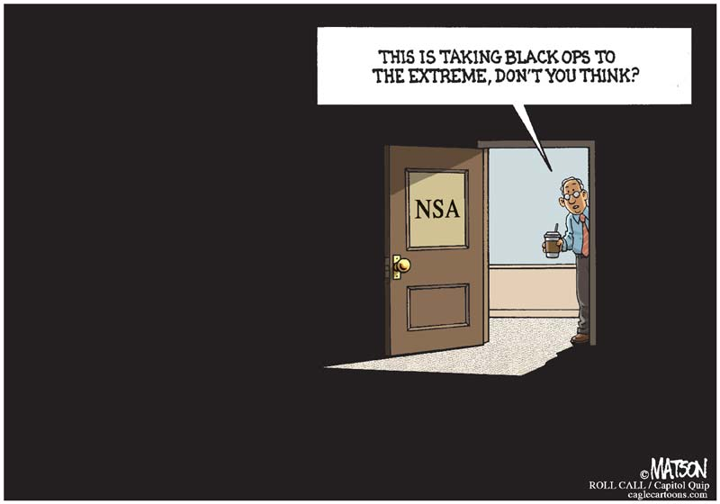
NSA Operates in the Dark-COLOR by R.J. Matson, Roll Call
Source 6
Russian interference in the 2016 United States elections
From Wikipedia, the free encyclopedia
The Russian government interfered in the 2016 U.S. presidential election in order to increase political instability in the United States and to damage Hillary Clinton's presidential campaign by bolstering the candidacies of Donald Trump, Bernie Sanders and Jill Stein. A January 2017 assessment by the Office of the Director of National Intelligence (ODNI) stated that Russian leadership favored presidential candidate Trump over Clinton, and that Russian president Vladimir Putin personally ordered an "influence campaign" to harm Clinton's chances and "undermine public faith in the US democratic process."
On October 7, 2016, the ODNI and the Department of Homeland Security (DHS) jointly stated that the U.S. Intelligence Community was confident that the Russian Government directed recent hacking of emails with the intention of interfering with the U.S. election process. According to the ODNI's report on January 6, 2017, the Russian military intelligence service (GRU) had hacked the servers of the Democratic National Committee (DNC) and the personal Google email account of Clinton campaign chairman John Podesta and forwarded their contents to WikiLeaks. Although Russian officials have repeatedly denied involvement in any DNC hacks or leaks, there is strong forensic evidence linking the DNC breach to known Russian operations. In January 2017, Director of National Intelligence James Clapper testified that Russia had interfered in the elections by disseminating fake news promoted on social media. On July 13, 2018, 12 Russian military intelligence agents were indicted by Special Counsel Robert Mueller for allegedly hacking the email accounts and networks of Democratic Party officials.
On October 31, 2016, President Barack Obama warned Putin via the "red phone" to stop interfering or face consequences. In December 2016, Obama ordered a report on hacking efforts aimed at U.S. elections since 2008, while U.S. Senators called for a bipartisan investigation. President-elect Trump rejected claims of foreign interference and said that Democrats were reacting to their election loss. On December 29, 2016, the Obama Administration expelled 35 Russian diplomats, denied access to two Russia-owned compounds, and broadened existing sanctions on Russian entities and individuals. More sanctions were imposed against Russia by the Trump administration in March 2018, and on April 6, 2018, the Trump administration brought another new round of sanctions against Russia, targeting several oligarchs and high-ranking Russian officials. In June 2018, the United States Department of the Treasury implemented new sanctions on several Russian entities and officials in connection to cyberattacks by Russia related to the 2016 election interference. Several countries in the European Union have also pursued a sanctions regime against Russia, accusing the state of supporting terrorism and interfering in their own elections.
Investigations about Russian influence on the election include a counter-intelligence investigation by the FBI, hearings by the Senate Intelligence Committee and the House Intelligence Committee, and inquiries about possible links and financial ties between the Kremlin and Trump associates, notably targeting Paul Manafort, Carter Page and Roger Stone. On May 9, 2017, Trump dismissed FBI Director James Comey, citing in part dissatisfaction with suspicions of his presidency because of "this Russia thing." On May 17, Deputy Attorney General, and Acting Attorney General for this investigation Rod Rosenstein appointed former FBI Director Robert Mueller as Special Counsel to oversee the investigation.
In a testimony on February 13, 2018, before the Senate Intelligence Committee, the heads of the top six American intelligence agencies unanimously reaffirmed Russian interference. Three sources familiar with Trump's thinking told CNN he remains unconvinced that Russia interfered because it suggests he did not win the election solely on his own merits.
As of June 2018, at least 11 Trump associates or officials have admitted to having contacts with Russians during the campaign or transition.
Source 7
