Practice Test for Reading and Writing Nonfiction
Nonfiction Assessment IV
View and analyze source 1.
Student: |  | Date:
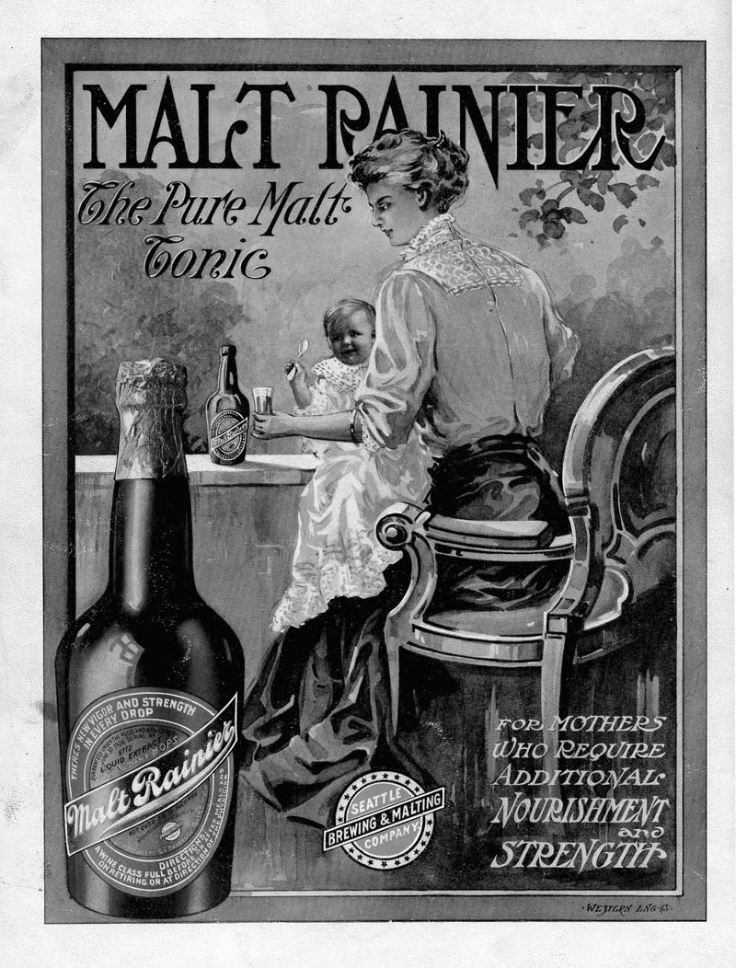

Note: The text on the bottle reads “There’s new vigor and strength in every drop / Guaranteed under the Food and Drugs Act / June 30 1908 Serial No 9772 / Liquid Extract of Malt and Hops / Malt Rainier / Not over 5 1/2% alcohol / Prepared and bottled exclusively by / Seattle Brewing & Malting Co Seattle Wash. / Directions: A wine glass full before or after meals and on retiring or at direction of the physician.”
- Who does this ad target?
- Lower-class women
- Exhausted mothers
- Beer drinkers
- Medical professionals who can prescribe tonics
- What best describes Malt Rainier Tonic?
- Medicine
- Liquid extract of malt and hops not over 5 1/2 percent alcohol
- Nourishment
- Strength for mothers
- Infer why the ad shows a well-dressed, upper-class woman with nicely-styled hair.
- Advertisers wanted to make their tonic seem like legitimate medicine rather than simply malt liquor.
- Advertisers knew that all mothers would aspire to be wealthy, upper-class, beautiful, and respectable.
- Advertisers wanted to sell their product to only this type of mother.
- Both A and B might be reasons.
- Which of the following can you infer about the Food and Drugs Act of 1908?
- The United States has always carefully safeguarded the health of mothers.
- The Food and Drug Administration was founded in 1908.
- In 1908, laws governing the marketing of alcohol were different than they are today.
- The Seattle Brewing and Malting Company had paid off federal investigators.
- For modern viewers, what is the most shocking claim of this advertisement?
- Mothers should drink alcohol while caring for their children.
- Malt Rainier contains no more than 5 1/2 percent alcohol.
- Malt Rainier provides nourishment and strength.
- Exhausted mothers often attend the Argus Alaska-Yukon-Pacific Exposition.

