Practice Test for Reading and Writing Nonfiction
Nonfiction Assessment II
Closely read and respond to source 1.
Student: |  | Date:

Excerpt from "Citizenship in a Republic"
by Teddy Roosevelt
Former United States President Theodore Roosevelt delivered this speech on April 23, 1910, at the University of Paris.
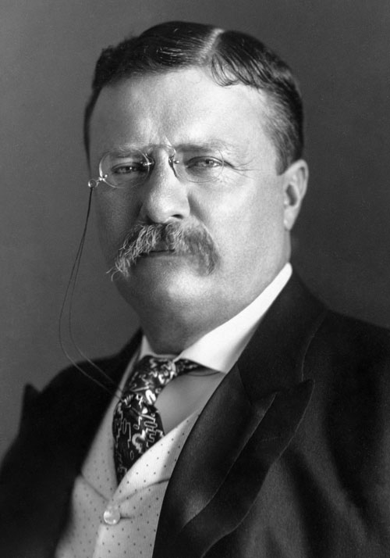
Teddy Roosevelt (United States Library of Congress's Prints and Photographs division)
1 . . . Let the man of learning, the man of lettered leisure, beware of that queer and cheap temptation to pose to himself and to others as a cynic, as the man who has outgrown emotions and beliefs, the man to whom good and evil are as one. The poorest way to face life is to face it with a sneer. There are many men who feel a kind of twisted pride in cynicism; there are many who confine themselves to criticism of the way others do what they themselves dare not even attempt. There is no more unhealthy being, no man less worthy of respect, than he who either really holds, or feigns to hold, an attitude of sneering disbelief toward all that is great and lofty, whether in achievement or in that noble effort which, even if it fails, comes to second achievement. A cynical habit of thought and speech, a readiness to criticise work which the critic himself never tries to perform, an intellectual aloofness which will not accept contact with life’s realities—all these are marks, not as the possessor would fain to think, of superiority but of weakness. They mark the men unfit to bear their part painfully in the stern strife of living, who seek, in the affection of contempt for the achievements of others, to hide from others and from themselves in their own weakness. The role is easy; there is none easier, save only the role of the man who sneers alike at both criticism and performance.
2 It is not the critic who counts; not the man who points out how the strong man stumbles, or where the doer of deeds could have done them better. The credit belongs to the man who is actually in the arena, whose face is marred by dust and sweat and blood; who strives valiantly; who errs, who comes short again and again, because there is no effort without error and shortcoming; but who does actually strive to do the deeds; who knows great enthusiasms, the great devotions; who spends himself in a worthy cause; who at the best knows in the end the triumph of high achievement, and who at the worst, if he fails, at least fails while daring greatly, so that his place shall never be with those cold and timid souls who neither know victory nor defeat. Shame on the man of cultivated taste who permits refinement to develop into fastidiousness that unfits him for doing the rough work of a workaday world. Among the free peoples who govern themselves there is but a small field of usefulness open for the men of cloistered life who shrink from contact with their fellows. Still less room is there for those who deride of slight what is done by those who actually bear the brunt of the day; nor yet for those others who always profess that they would like to take action, if only the conditions of life were not exactly what they actually are. The man who does nothing cuts the same sordid figure in the pages of history, whether he be a cynic, or fop, or voluptuary. There is little use for the being whose tepid soul knows nothing of great and generous emotion, of the high pride, the stern belief, the lofty enthusiasm, of the men who quell the storm and ride the thunder. Well for these men if they succeed; well also, though not so well, if they fail, given only that they have nobly ventured, and have put forth all their heart and strength. It is war-worn Hotspur, spent with hard fighting, he of the many errors and valiant end, over whose memory we love to linger, not over the memory of the young lord who “but for the vile guns would have been a valiant soldier.” . . .
3 Let those who have, keep, let those who have not, strive to attain, a high standard of cultivation and scholarship. Yet let us remember that these stand second to certain other things. There is need of a sound body, and even more of a sound mind. But above mind and above body stands character—the sum of those qualities which we mean when we speak of a man’s force and courage, of his good faith and sense of honor. I believe in exercise for the body, always provided that we keep in mind that physical development is a means and not an end. I believe, of course, in giving to all the people a good education. But the education must contain much besides book-learning in order to be really good. We must ever remember that no keenness and subtleness of intellect, no polish, no cleverness, in any way make up for the lack of the great solid qualities. Self restraint, self mastery, common sense, the power of accepting individual responsibility and yet of acting in conjunction with others, courage and resolution—these are the qualities which mark a masterful people. Without them no people can control itself, or save itself from being controlled from the outside. I speak to brilliant assemblage; I speak in a great university which represents the flower of the highest intellectual development; I pay all homage to intellect and to elaborate and specialized training of the intellect; and yet I know I shall have the assent of all of you present when I add that more important still are the commonplace, every-day qualities and virtues.
4 Such ordinary, every-day qualities include the will and the power to work, to fight at need, and to have plenty of healthy children. The need that the average man shall work is so obvious as hardly to warrant insistence. There are a few people in every country so born that they can lead lives of leisure. These fill a useful function if they make it evident that leisure does not mean idleness; for some of the most valuable work needed by civilization is essentially non-remunerative in its character, and of course the people who do this work should in large part be drawn from those to whom remuneration is an object of indifference. But the average man must earn his own livelihood. He should be trained to do so, and he should be trained to feel that he occupies a contemptible position if he does not do so; that he is not an object of envy if he is idle, at whichever end of the social scale he stands, but an object of contempt, an object of derision.
5 In the next place, the good man should be both a strong and a brave man; that is, he should be able to fight, he should be able to serve his country as a soldier, if the need arises. There are well-meaning philosophers who declaim against the unrighteousness of war. They are right only if they lay all their emphasis upon the unrighteousness. War is a dreadful thing, and unjust war is a crime against humanity. But it is such a crime because it is unjust, not because it is a war. The choice must ever be in favor of righteousness, and this is whether the alternative be peace or whether the alternative be war. The question must not be merely, Is there to be peace or war? The question must be, Is it right to prevail? Are the great laws of righteousness once more to be fulfilled? And the answer from a strong and virile people must be “Yes,” whatever the cost. Every honorable effort should always be made to avoid war, just as every honorable effort should always be made by the individual in private life to keep out of a brawl, to keep out of trouble; but no self-respecting individual, no self-respecting nation, can or ought to submit to wrong. . . .
- Which statement best describes the speech's thesis?
- Intellectuals are tepid souls who know "nothing of greatness and generous emotion."
- Doers such as Teddy Roosevelt should never be criticized by people who do nothing.
- The only people of value are those who fight in wars.
- Intellectual pursuits are secondary to pragmatic action, and strong character.
- Which quotation best expresses Roosevelt's view of a sound character?
- "The credit belongs to the man who is actually in the arena, whose face is marred by dust and sweat and blood."
- "Self restraint, self mastery, common sense, the power of accepting individual responsibility and yet of acting in conjunction with others, courage and resolution"
- "There is need of a sound body, and even more of a sound mind."
- "[T]he good man should be both a strong and a brave man; that is, he should be able to fight, he should be able to serve his country as a soldier, if the need arises."
- In the first paragraph, use context clues to select the best definition of “affection of contempt for the achievements of others.”
- Pretending to hate what others accomplish
- Fondness for disliking what others accomplish
- Sneering facial expression of dismissal
- Aloofness about pragmatic solutions
- In the second paragraph, use context clues to select the best definition of "cloistered."
- Monastic
- Sheltered, kept safe from the world
- Gathered together in a central place
- Academic
- In the third paragraph, what is Roosevelt referring to when he says, "Let those who have, keep, let those who have not, strive to attain"?
- Worldly possessions
- Land
- Meaningful employment
- Learning
- In the fourth paragraph, what does Roosevelt mean by "those to whom remuneration is an object of indifference"?
- People who do not need money
- People who are selfless
- People who do not care about mathematics
- People who judge by character instead of appearance
- In the fourth paragraph, what does Roosevelt consider to be "an object of contempt, an object of derision"?
- Those who do not fight in war
- Intellectual criticism
- Those who do not earn their own livelihood
- War
- In the fifth paragraph, which quotation best encapsulates Roosevelt's view of war.
- "War is a dreadful thing, and unjust war is a crime against humanity."
- "But it is such a crime because it is unjust, not because it is a war."
- "And the answer from a strong and virile people must be 'Yes,' whatever the cost."
- "Every honorable effort should always be made to avoid war, just as every honorable effort should always be made by the individual in private life to keep out of a brawl, to keep out of trouble; but no self-respecting individual, no self-respecting nation, can or ought to submit to wrong."
- What best describes the purpose of this speech?
- To explain the character traits of good citizens
- To inspire academics to take action
- To silence critics
- To warn against too much education
- Which quotation would be the best alternate title for this selection?
- "Intellectual Aloofness"
- "Cold and Timid Souls"
- "The Man in the Arena"
- "Is It Right to Prevail?"

