Words in Write Away
Name: |  | Date:

Directions Fill in the blank boxes below with words from the Write Away chapters at the top of the chart. Each word should begin with the letter at the side of the chart.
 | Using Phonics  (pages 199-209) | Checking Your Spelling  (pages 276-283) | Using Theme Words  (pages 300-303)
w | wagon
r
i
t |  |  | 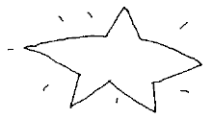
e

© Thoughtful Learning From Write Away

