**Up, Up, and Away!**

Name: ______________________________________________

**Directions:** Open your *Write Away* handbook to page 3. Read about the five parts of *Write Away.* Fill in the missing words and color the balloons.

**____________**

**Almanac**

**The __________**

**of Learning**

**Proofreader’s**

**___________**

**The Process of**

**_____________**

**The __________**

**of Writing**

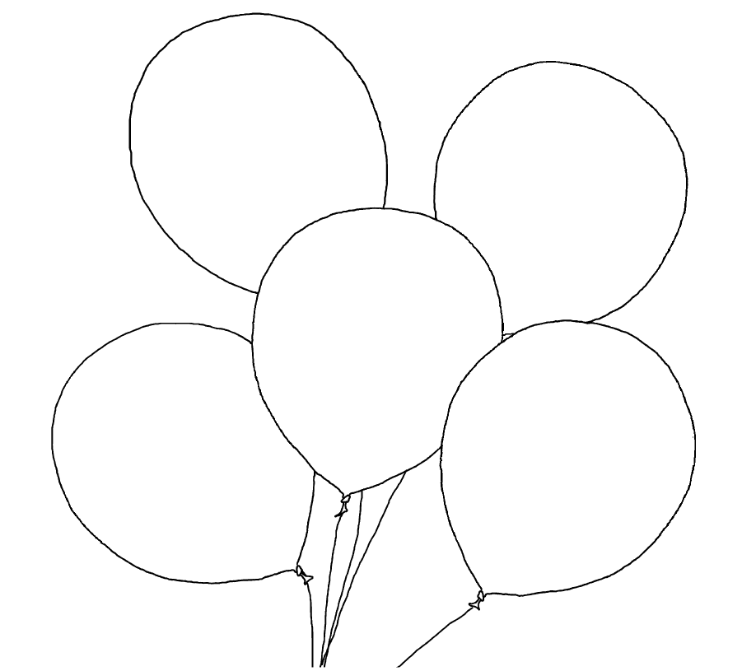

© [Thoughtful Learning](https://k12.thoughtfullearning.com) From [*Write Away*](https://k12.thoughtfullearning.com/products/write-away)