Writing Rubric
Name: |  | Title:
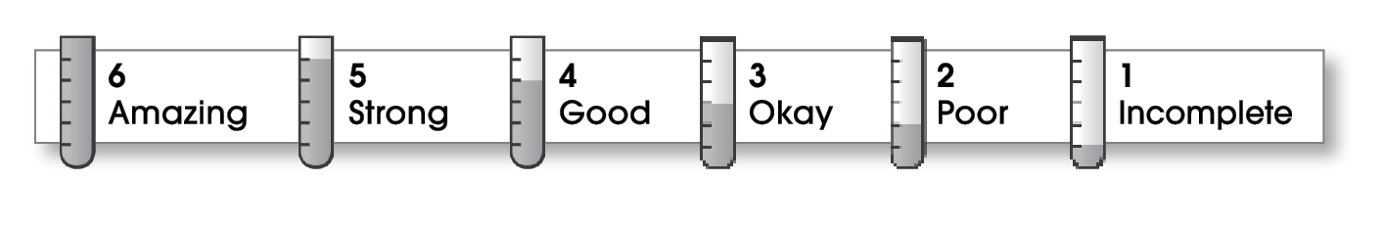

Structure
- The writing contains a beginning, a middle, and an ending.
- The beginning contains a strong lead sentence and names the focus or thesis.
- The middle paragraphs support the focus.
- The ending restates the focus and gives an important final thought.
- The writing follows one main pattern of organization.
Ideas
- The writing has an interesting topic, a clear focus or thesis, and strong support.
- The writing uses specific words and varied, smooth reading sentences.
- The words and sentences match the writer’s purpose and assignment.
- The language sounds sincere and natural.
Conventions
- The writing follows the basic rules of grammar, spelling, and punctuation.
- Words are capitalized correctly.

Comments:

© Thoughtful Learning For Writers Express

