Narrative Rubric
Name: |  | Title: | When I Got Burned on Dad’s Motorcycle
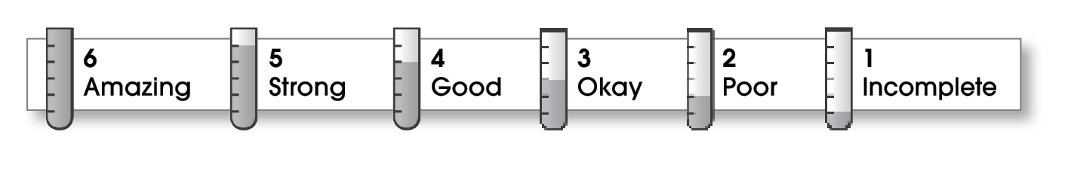

5 | Structure
The writing . . .
- focuses on a specific experience or time in the writer’s life.
- pulls the reader into the story.
- includes a beginning, a middle, and an ending.
- gives the events in an order that is easy to follow.
5 | Ideas
- answers the 5 W’s (Who? What? When? Where? Why?) about the experience.
- uses sensory details and dialogue to make the story come alive.
- uses specific words to give the reader a clear picture.
- sounds honest and engaging.
- flows smoothly from one idea to the next.
6 | Conventions
- is free of most errors in grammar, punctuation, and spelling.
- uses the format provided by the teacher or follows another effective design.

Comments: Your story starts out strong and holds the reader’s attention all the way through. Sharing your thoughts and feelings and including excellent dialogue really make your writing come alive. Punctuating dialogue can be tricky, but it’s obvious you spent a lot of time proofreading your final copy, since your work is free of errors.

© Thoughtful Learning For Writers Express

