Literature Response Rubric
Name: |  | Title: | The Year Mom Won the Pennant
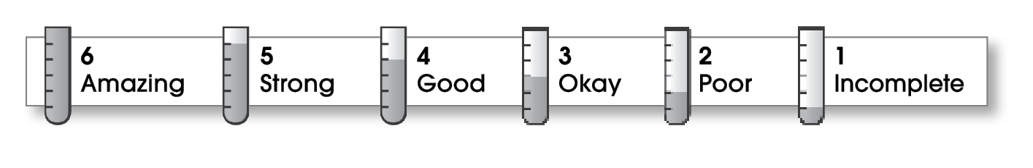

5 | Structure
The writing . . .
- contains an effective beginning, middle, and ending.
- presents a clearly stated focus or opinion statement.
- includes transitions as needed to connect ideas and paragraphs.
5 | Ideas
- reflects the writer’s clear understanding of the literature.
- includes specific details and quotations from the text to develop or support the thesis.
- sounds believable and informed.
- exhibits a careful choice of words.
- flows smoothly from one idea to the next.
5 | Conventions
- follows the standards for punctuation, capitalization, spelling, and grammar.
- cites quotations correctly.

Comments: You do a great job of organizing your responses to this book. Your voice comes through loud and clear. It’s obvious that you liked this book and think others should read it.
You cover the various elements (plot, theme, overall reaction) in your review. A few more specific details from the story would have made it even better. Finally, your paper is easy to read and free of errors in spelling and punctuation.

© Thoughtful Learning For Writers Express

