Narrative Rubric
Name: |  | Title: | The Trip to the Woods
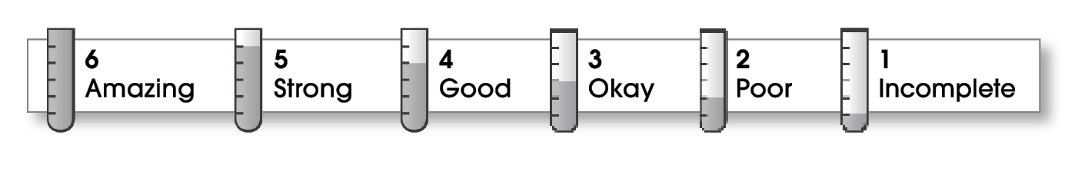

2 | Structure
The writing . . .
- focuses on a specific experience or time in the writer’s life.
- pulls the reader into the story.
- includes a beginning, a middle, and an ending.
- gives the events in an order that is easy to follow.
2 | Ideas
- answers the 5 W’s (Who? What? When? Where? Why?) about the experience.
- uses sensory details and dialogue to make the story come alive.
- uses specific words to give the reader a clear picture.
- sounds honest and engaging.
- flows smoothly from one idea to the next.
2 | Conventions
- is free of most errors in grammar, punctuation, and spelling.
- uses the format provided by the teacher or follows another effective design.

Comments: It sounds like you had fun camping. Your story made me laugh! Your narrative skipped around, though, making it hard to follow. Using words like “the first day,” “after that,” and “the last day in the woods” would help you improve the structure of your story.
If you described your biking adventure or your eating-out experience in more detail, it might be more interesting than just a list of all the different things that happened. Also be sure you do a final check for spelling and grammar errors.

© Thoughtful Learning For Writers Express

