Explanatory Rubric
Name: |  | Title: | The Person I Want to Be
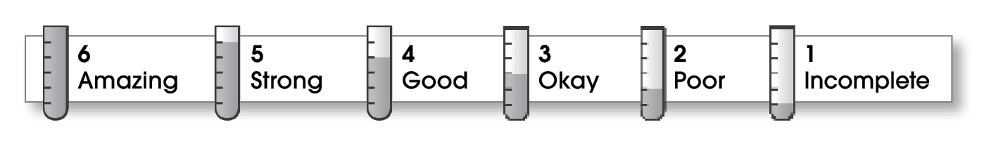

3 | Structure
The writing . . .
- begins by introducing the topic and providing a clear focus statement.
- includes a middle part that supports the focus.
- organizes supporting details in a logical pattern.
- ends by summarizing the important ideas and giving the reader a final thought.
2 | Ideas
- includes strong details to develop the topic.
- effectively combines details to fully explain important points.
- uses specific words to give the reader a clear understanding of the topic.
- uses a variety of sentence lengths and beginnings.
- sounds serious and interested.
3 | Conventions
- uses end punctuation and commas correctly.
- correctly capitalizes first words and proper nouns.
- avoids spelling errors.
- correctly uses words (there, they’re, their).

Comments: You have an interesting reason for wanting to be president. You start with a strong point. However, you need to discover more about what the president does on a typical day. You need facts and specific examples for this type of essay. Remember, each paragraph needs a topic sentence and other sentences with details to support that topic.
You should avoid slang words like “awesome” in a formal essay. Your conclusion could be expanded by listing what you believe would make a “good president.”

© Thoughtful Learning For Writers Express

