Literature Response Rubric
Name: |  | Title: | The Cat Ate My Gymsuit
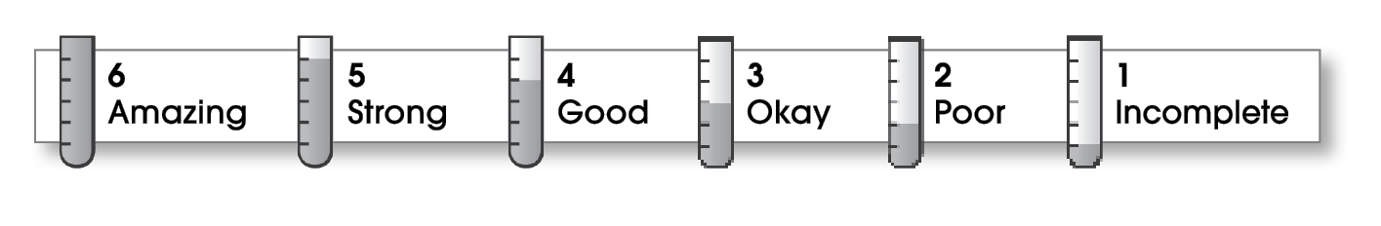

2 | Structure
The writing . . .
- contains an effective beginning, middle, and ending.
- presents a clearly stated focus or opinion statement.
- includes transitions as needed to connect ideas and paragraphs.
2 | Ideas
- reflects the writer’s clear understanding of the literature.
- includes specific details and quotations from the text to develop or support the thesis.
- sounds believable and informed.
- exhibits a careful choice of words.
- flows smoothly from one idea to the next.
2 | Conventions
- follows the standards for punctuation, capitalization, spelling, and grammar.
- cites quotations correctly.

Comments: This is a great book to choose to review, and I’m glad that you read it. You also pay careful attention to your spelling.
You need to share more specific details about the book. Readers need to know the main characters’ names and the name of the author as well.
Be sure to indent your paragraphs and begin new paragraphs when you start each new idea (like how the beginning hooked you and again when you talk about the main characters).

© Thoughtful Learning For Writers Express

