Teacher Rating Sheet
Name: |  | Title:
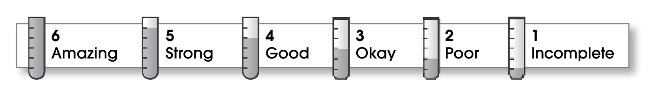

Structure
Great lead!  Logical order  Clear transitions  Powerful ending |  |  |  |  |  |  | No real lead  Confusing order  Disconnected ideas  No conclusion
 | 6 |  | 5 | 4 | 3 | 2 | 1
Ideas
Clear and focused  Rich in detail  Voice fits purpose  Strong nouns/verbs  Easy/fun to read  Varied sentences |  |  |  |  |  |  | Fuzzy and disjointed  General, sketch  Inappropriate voice  Weak nouns/verbs  Hard/bad to read  Repetitive
 | 6 |  | 5 | 4 | 3 | 2 | 1
Conventions
Correct copy  Attention to detail  Effective design |  |  |  |  |  |  | Error filled  Sloppy  Ineffective design
 |  | 6 | 5 | 4 | 3 | 2 | 1

© Thoughtful Learning For Writers Express

