Narrative Rubric
Name: |  | Title:
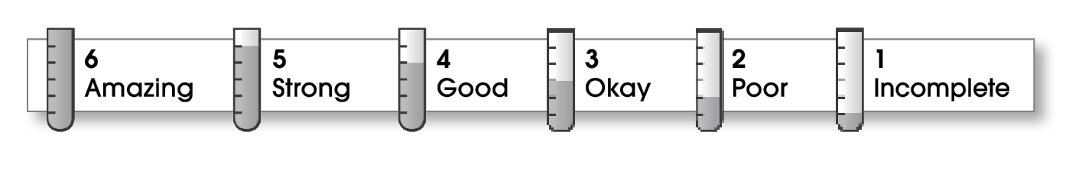

Structure
The writing . . .
- focuses on a specific experience or time in the writer’s life.
- pulls the reader into the story.
- includes a beginning, a middle, and an ending.
- gives the events in an order that is easy to follow.
Ideas
- answers the 5 W’s (Who? What? When? Where? Why?) about the experience.
- uses sensory details and dialogue to make the story come alive.
- uses specific words to give the reader a clear picture.
- sounds honest and engaging.
- flows smoothly from one idea to the next.
Conventions
- is free of most errors in grammar, punctuation, and spelling.
- uses the format provided by the teacher or follows another effective design.

Comments:

© Thoughtful Learning For Writers Express

