Narrative Rubric
Name: |  | Title: | My Worst Scrape
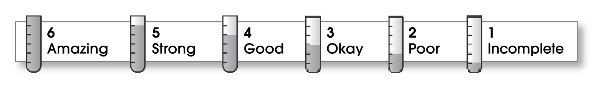

3 | Structure
The writing . . .
- focuses on a specific experience or time in the writer’s life.
- pulls the reader into the story.
- includes a beginning, a middle, and an ending.
- gives the events in an order that is easy to follow.
3 | Ideas
- answers the 5 W’s (Who? What? When? Where? Why?) about the experience.
- uses sensory details and dialogue to make the story come alive.
- uses specific words to give the reader a clear picture.
- sounds honest and engaging.
- flows smoothly from one idea to the next.
4 | Conventions
- is free of most errors in grammar, punctuation, and spelling.
- uses the format provided by the teacher or follows another effective design.

Comments: Your writing shows that you know how to write a story. By adding more dialogue and sensory details, you could really make your story come to life for your readers. Try to make them feel like they are right there with you. Also, more variety of sentence lengths would help to make your writing less choppy.
You did a good job of proofreading for spelling. There are several sentences that still need commas. It’s a good thing your injury wasn’t too serious!

© Thoughtful Learning For Writers Express

