Literature Response Rubric
Name: |  | Title: | Keep Reading!
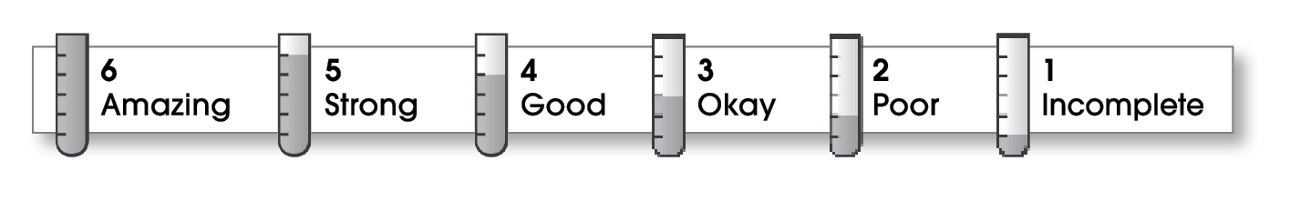

3 | Structure
The writing . . .
- contains an effective beginning, middle, and ending.
- presents a clearly stated focus or opinion statement.
- includes transitions as needed to connect ideas and paragraphs.
3 | Ideas
- reflects the writer’s clear understanding of the literature.
- includes specific details and quotations from the text to develop or support the thesis.
- sounds believable and informed.
- exhibits a careful choice of words.
- flows smoothly from one idea to the next.
4 | Conventions
- follows the standards for punctuation, capitalization, spelling, and grammar.
- cites quotations correctly.

Comments: The letter form is a fine choice for a response to this book. It’s clear that you liked the book. You could use more specific details from the book. For example, what makes it easy to read? What makes Danziger’s books interesting? What are some of the gross things Amber says? Adding these kinds of details would add interest and make this review a good or even an excellent response.
Perhaps your conclusion could also say why other readers would enjoy this book.

© Thoughtful Learning For Writers Express

