Literature Response Rubric
Name: |  | Title: | Homecoming
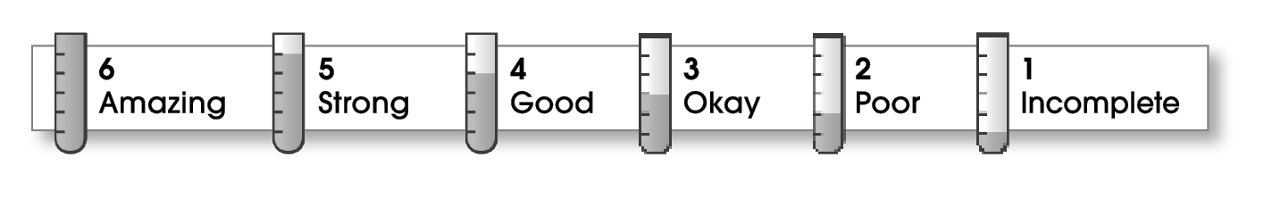

2 | Structure
The writing . . .
- contains an effective beginning, middle, and ending.
- presents a clearly stated focus or opinion statement.
- includes transitions as needed to connect ideas and paragraphs.
2 | Ideas
- reflects the writer’s clear understanding of the literature.
- includes specific details and quotations from the text to develop or support the thesis.
- sounds believable and informed.
- exhibits a careful choice of words.
- flows smoothly from one idea to the next.
2 | Conventions
- follows the standards for punctuation, capitalization, spelling, and grammar.
- cites quotations correctly.

Comments: This is a long book, and not an easy one to read. Good for you for sticking with it.
Your first paragraph needs to be clearer: first you say it was a good book, and then you say it was too long and confusing. Also work on structure. Put similar ideas together and discuss the book in the order that events happened.
Remember to name the author. I know the book was written by Cynthia Voigt, but other readers may not. Be sure to mention the name of the book in your review. You might save your recommendation for the conclusion.

© Thoughtful Learning For Writers Express

