Literature Response Rubric
Name: |  | Title: | Falling Up
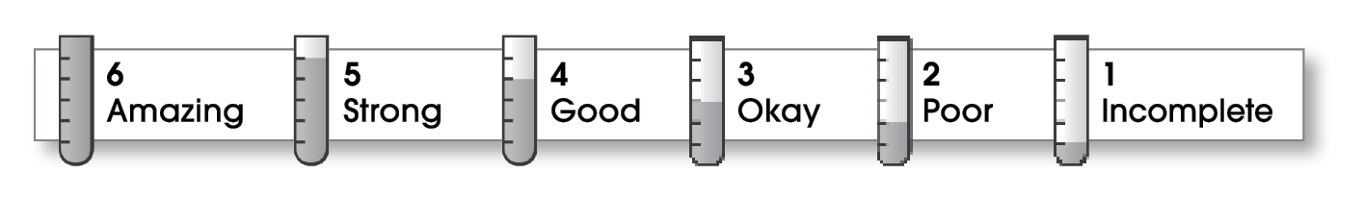

3 | Structure
The writing . . .
- contains an effective beginning, middle, and ending.
- presents a clearly stated focus or opinion statement.
- includes transitions as needed to connect ideas and paragraphs.
3 | Ideas
- reflects the writer’s clear understanding of the literature.
- includes specific details and quotations from the text to develop or support the thesis.
- sounds believable and informed.
- exhibits a careful choice of words.
- flows smoothly from one idea to the next.
3 | Conventions
- follows the standards for punctuation, capitalization, spelling, and grammar.
- cites quotations correctly.

Comments: This does sound like a fun book to read, but you need to use more details to bring it to life. For example, you could have chosen one character to describe and maybe quoted a line or two from the poem.
You need to reorganize some of your ideas (the sentence about characters in the last paragraph belongs with paragraph two). Making a plan before you write might be helpful.
© Thoughtful Learning For Writers Express

