Literature Response Rubric
Name: |  | Title: | A Shipwreck at the Bottom of the World
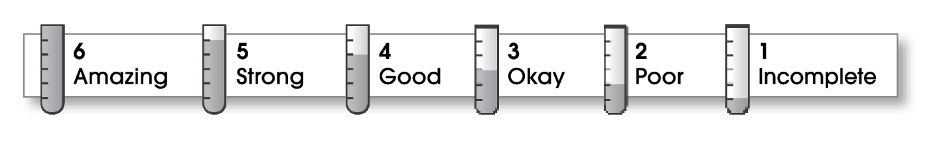

4 | Structure
The writing . . .
- contains an effective beginning, middle, and ending.
- presents a clearly stated focus or opinion statement.
- includes transitions as needed to connect ideas and paragraphs.
5 | Ideas
- reflects the writer’s clear understanding of the literature.
- includes specific details and quotations from the text to develop or support the thesis.
- sounds believable and informed.
- exhibits a careful choice of words.
- flows smoothly from one idea to the next.
5 | Conventions
- follows the standards for punctuation, capitalization, spelling, and grammar.
- cites quotations correctly.

Comments: Your book review is very well organized and free of mechanical errors, so it is easy to read and understand. You use a lot of details from the book that make it clear that you have carefully read the whole book. You are also careful not to give the whole story away.
Your voice comes through clearly in paragraph three as does your enthusiasm for this book. Your introduction could be stronger. Try to pull the reader in with an interesting quotation or question.

© Thoughtful Learning For Writers Express

