Literature Response Rubric
Name: |  | Title: | A Letter of Recommendation
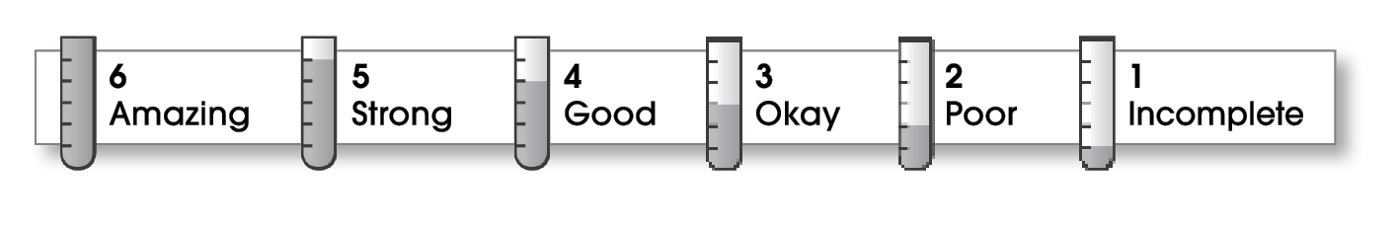

4 | Structure
The writing . . .
- contains an effective beginning, middle, and ending.
- presents a clearly stated focus or opinion statement.
- includes transitions as needed to connect ideas and paragraphs.
4 | Ideas
- reflects the writer’s clear understanding of the literature.
- includes specific details and quotations from the text to develop or support the thesis.
- sounds believable and informed.
- exhibits a careful choice of words.
- flows smoothly from one idea to the next.
4 | Conventions
- follows the standards for punctuation, capitalization, spelling, and grammar.
- cites quotations correctly.

Comments: Using a letter makes your response very personal, and it reflects the form of the book you chose to review as well!
Your writing could use a few more details; try using actual quotations or lines from the book. It would help to hear Leigh’s feelings in his own words, and it would add life to your review.
Finally, be sure to give credit to the author somewhere in your review. In this case, it’s the well-known Beverly Cleary. Maybe you should send her this letter and ask for the sequel you want!

© Thoughtful Learning For Writers Express

