Narrative Rubric
Name: |  | Title: | Thunderstorm Rubric
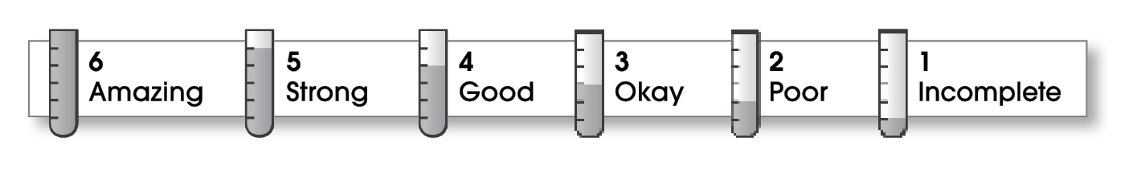

5 | Structure
The writing . . .
- begins with action or a very brief explanation.
- describes the events and actions of the story in the middle part.
- organizes ideas effectively.
- ends with a final action or final thought.
6 | Ideas
- includes all the important actions and details.
- uses sensory details to describe how things look, sound, smell, or taste.
- uses specific verbs to describe action (sprint instead of ran).
- includes personal feelings.
- includes dialogue between characters.
- includes sentences that are easy to read and understand.
5 | Conventions
- is free of most errors in grammar, punctuation, and spelling.
- uses quotation marks around dialogue.

Comments: Your paragraph really brings this storm to life. You use many sights and sounds. Verbs like “cracked” capture the action. What a strange sound for a toad to make!

© Thoughtful Learning For Write on Track

