Teacher Rating Sheet
Name: |  | Title:
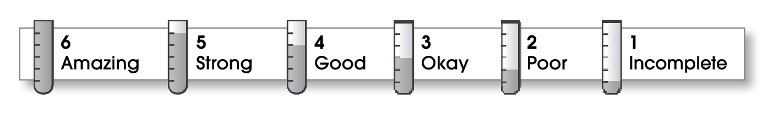

Structure
Great start!  Detailed middle  Logical order  Interesting ending |  |  |  |  |  |  | No real opening  No explanation  Confusing order  No conclusion
 | 6 |  | 5 | 4 | 3 | 2 | 1
Ideas
Clear topic  Interesting details  Specific words  Varied sentences  Easy/fun to read |  |  |  |  |  |  | No real topic named  Lacks details  General words  Repetitive  Difficult to read
 | 6 |  | 5 | 4 | 3 | 2 | 1
Conventions
Correct copy  Attention to detail |  |  |  |  |  |  | Error filled  Sloppy
 |  | 6 | 5 | 4 | 3 | 2 | 1

© Thoughtful Learning For Writers Express

