Explanatory Rubric
Name: |  | Title: | Planting a Garden
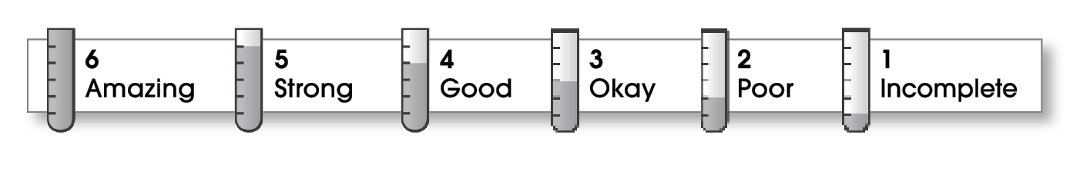

4 | Structure
The writing . . .
- begins by introducing the topic and telling what the writing will be about.
- includes a middle part that explains different parts of the topic.
- organizes ideas effectively.
- ends by restating an important idea or sharing what you learned.
3 | Ideas
- explains an interesting topic.
- gives specific details about different parts of the topic.
- uses specific words.
- uses a variety of sentence lengths and beginnings.
3 | Conventions
- uses end punctuation correctly.
- capitalizes first words and proper nouns.
- spells names and key words correctly.

Comments: Your first sentence is a nice invitation. The kinds of seeds to use and how to plant them need more explaining. Always do a final check for capital letters and end punctuation.

© Thoughtful Learning For Write on Track

