Explanatory Rubric
Name: |  | Title: | Our Horses
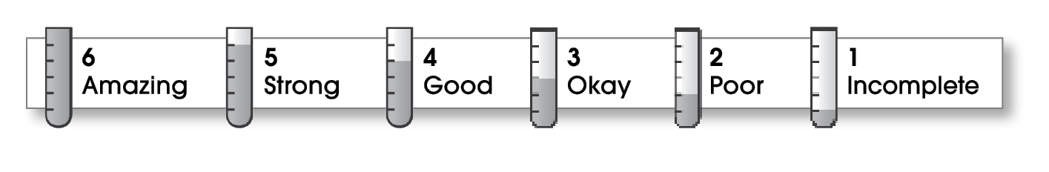

4 | Structure
The writing . . .
- begins by introducing the topic and telling what the writing will be about.
- includes a middle part that explains different parts of the topic.
- organizes ideas effectively.
- ends by restating an important idea or sharing what you learned.
4 | Ideas
- explains an interesting topic.
- gives specific details about different parts of the topic.
- uses specific words.
- uses a variety of sentence lengths and beginnings.
5 | Conventions
- uses end punctuation correctly.
- capitalizes first words and proper nouns.
- spells names and key words correctly.

Comments: You include sights, sounds, and smells. Clearly you enjoy your horses a lot. Perhaps you could tell more about what the horses look like—their color, size, markings, and so on

© Thoughtful Learning For Write on Track

