Explanatory Rubric
Name: |  | Title: | My Favorit Lake
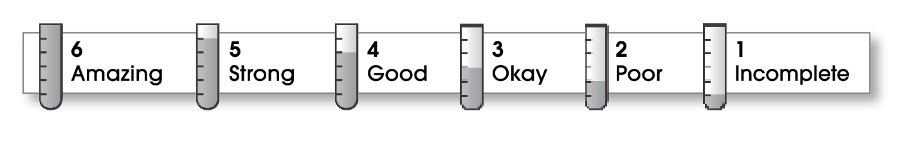

4 | Structure
The writing . . .
- begins by introducing the topic and telling what the writing will be about.
- includes a middle part that explains different parts of the topic.
- organizes ideas effectively.
- ends by restating an important idea or sharing what you learned.
3 | Ideas
- explains an interesting topic.
- gives specific details about different parts of the topic.
- uses specific words.
- uses a variety of sentence lengths and beginnings.
3 | Conventions
- uses end punctuation correctly.
- capitalizes first words and proper nouns.
- spells names and key words correctly.

Comments: Instead of having your first sentence repeat the title, you could begin by describing the water and the sand. That would make it sound more like your own favorite lake. Be sure to check your spelling.

© Thoughtful Learning For Write on Track

