Explanatory Rubric
Name: |  | Title: | Make a Blow-Up Box
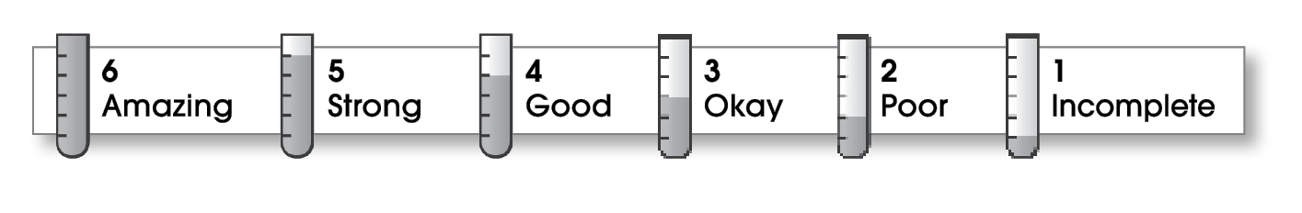

4 | Structure
The writing . . .
- begins by introducing the topic and telling what the writing will be about.
- includes a middle part that explains different parts of the topic.
- organizes ideas effectively.
- ends by restating an important idea or sharing what you learned.
3 | Ideas
- explains an interesting topic.
- gives specific details about different parts of the topic.
- uses specific words.
- uses a variety of sentence lengths and beginnings.
5 | Conventions
- uses end punctuation correctly.
- capitalizes first words and proper nouns.
- spells names and key words correctly.

Comments: You have created a good paragraph with very few errors. You obviously are interested in your topic, and readers are as well. This topic, however, is very hard to clearly describe with just words. Perhaps you could draw some pictures to show how to make each fold.

© Thoughtful Learning For Write on Track

