Explanatory Rubric
Name: |  | Title: | How to Pull a tooth
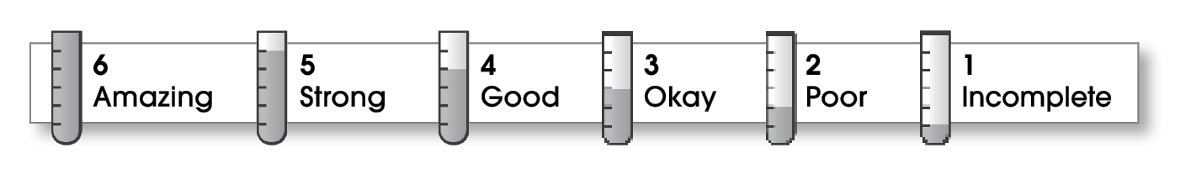

1 | Structure
The writing . . .
- begins by introducing the topic and telling what the writing will be about.
- includes a middle part that explains different parts of the topic.
- organizes ideas effectively.
- ends by restating an important idea or sharing what you learned.
2 | Ideas
- explains an interesting topic.
- gives specific details about different parts of the topic.
- uses specific words.
- uses a variety of sentence lengths and beginnings.
1 | Conventions
- uses end punctuation correctly.
- capitalizes first words and proper nouns.
- spells names and key words correctly.

Comments: You describe two ways to pull a tooth. What is the old-fashioned way? Also you need to have someone help you with your spelling.

© Thoughtful Learning For Write on Track

