Workplace Writing Rubric
Name: |  | Title: | Using Hydrochloric Acid (Fair)
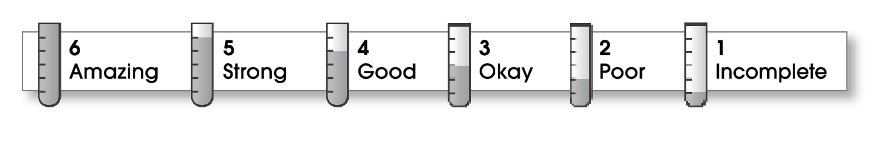

2 | Ideas
The writing . . .
- has a clear, central message.
- provides details that support the central message.
2 | Organization
- begins by capturing the reader’s interest and introducing the message.
- develops the message in the middle paragraphs.
- ends by reviewing the message or making a call to action.
3 | Voice
- sounds knowledgeable and informed.
- speaks in a voice appropriate to the audience.
3 | Word Choice
- uses precise nouns and active verbs.
3 | Sentence Fluency
- uses a variety of sentence lengths and beginnings.
- flows smoothly from one sentence to another.
3 | Conventions
- uses end punctuation and commas correctly.
- correctly capitalizes first words and proper nouns.
- avoids spelling errors.
- correctly uses words (there, they’re, their).
- follows the correct format for the type of message.

Comments: You seem to know quite a bit about your subject, but, in parts of your document, you did not explain yourself thoroughly. It’s good that you used paragraphs; however, they are underdeveloped.
Have a trusted editor check for word choice, clarity, and accuracy before submitting your work.

© Thoughtful Learning For Write on Course 20-20 and All Write

