Research Rubric
Name: |  | Title: | Tornadoes
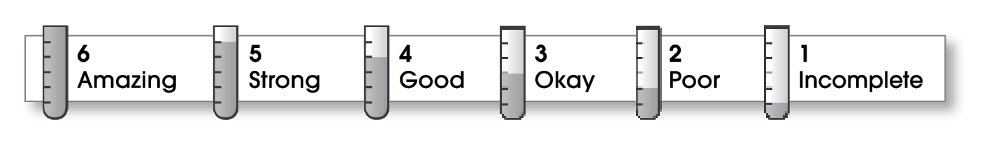

4 | Ideas
The writing . . .
- includes a thesis statement that focuses on an interesting aspect of the topic.
- effectively supports the thesis.
- thoroughly informs readers.
- gives credit, when necessary, for ideas from other sources.
4 | Organization
- includes a clearly developed beginning, middle, and ending.
- presents supporting information in an organized manner (perhaps one main idea per paragraph).
4 | Voice
- speaks in a sincere and knowledgeable way.
- shows that the writer is truly interested in the subject.
4 | Word Choice
- explains or defines any unfamiliar terms.
- employs an appropriate level of language.
3 | Sentence Fluency
- flows smoothly from one idea to the next.
4 | Conventions
- adheres to the rules of grammar, spelling, and punctuation.
- follows the appropriate format for research papers (including correct documentation).

Comments: Your paper presents effective information about tornadoes. However, better transitions between paragraphs, and more thoroughly developed opening and closing paragraphs, would have made your report easier to read.
In your paragraph on tornado safety, you switch from second (you) to third person (he, she, or they). Stick with third person throughout.
Finally, you need dates and publishers in your bibliography. Also check the format for listing multiple authors.
© Thoughtful Learning For Write on Course 20-20 and All Write

