Response Rubric
Name: |  | Title: | To Kill a Mockingbird
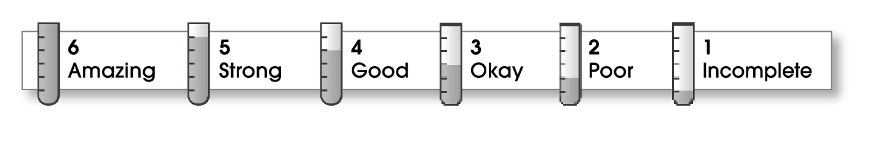

2 | Ideas
The writing . . .
- presents a clearly stated thesis that focuses on plot, characterization, setting, or theme.
- includes specific details and quotations from the text to develop or support the thesis.
3 | Organization
- follows a specific pattern of organization: chronological, order of importance, or logical order.
- contains an effective beginning, middle, and ending.
- includes transitions as needed to connect ideas and paragraphs.
3 | Voice
- sounds believable and informed.
- reflects the writer’s clear understanding of the literature.
3 | Word Choice
- exhibits a careful choice of words.
- explains unfamiliar terms.
3 | Sentence Fluency
- flows smoothly from one idea to the next.
2 | Conventions
- follows the standards for punctuation, capitalization, spelling, and grammar.
- cites quotations correctly.

Comments: Since you mention the themes of the novel in your opening paragraph, I was expecting you to identify and explain those themes throughout your response. Instead, you don’t mention any until the end. Boo Radley never speaks, so I’m not sure if you should call their meeting a “conversation.”
Use more details and examples from the novel to develop your points, and ask a trusted editor to check for errors before submitting your work.

© Thoughtful Learning For Write on Course 20-20 and All Write

