Explanatory Rubric
Name: |  | Title: | Gangs in Our Community
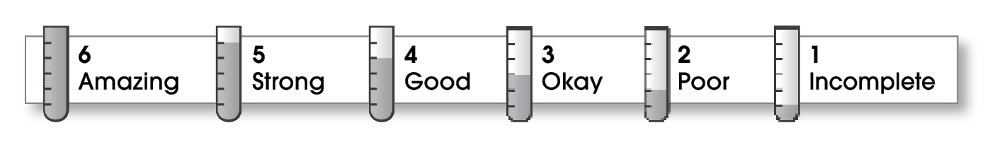

2 | Ideas
The writing . . .
- includes a clear, effective thesis statement.
- provides a variety of interesting details to support it.
2 | Organization
- begins by capturing the reader’s interest and providing the thesis statement.
- has an effectively organized middle.
- focuses on one main point for each middle paragraph.
- ends by summarizing the ideas and giving the reader a final thought.
3 | Voice
- has a voice that shows knowledge of the topic.
- has a voice that engages the reader.
2 | Word Choice
- uses precise nouns and active verbs.
1 | Sentence Fluency
- uses a variety of sentence lengths and beginnings.
- flows smoothly from one sentence to another.
1 | Conventions
- uses end punctuation and commas correctly.
- correctly capitalizes first words and proper nouns.
- avoids spelling errors.
- correctly uses words (there, they’re, their).

Comments: Your essay addresses a very important subject, but it lacks a specific thesis or focus statement. In addition, a reader needs more specific information that is clearly organized to better understand your subject.
You have a forceful writing voice; but sentence, grammar, and spelling errors make your writing hard to follow. Work with a trusted editor before completing a final copy.

© Thoughtful Learning For Write on Course 20-20 and All Write

