Research Rubric
Name: |  | Title: | The Great Pyramid
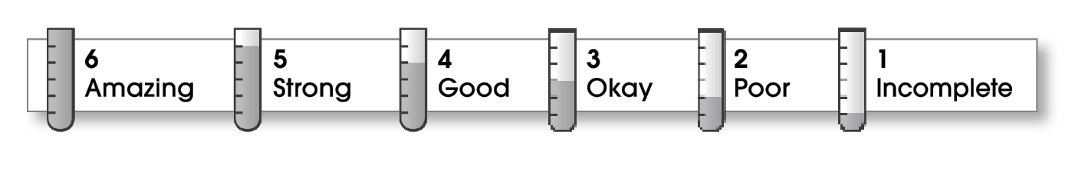

4 | Ideas
The writing . . .
- includes a thesis statement that focuses on an interesting aspect of the topic.
- effectively supports the thesis.
- thoroughly informs readers.
- gives credit, when necessary, for ideas from other sources.
3 | Organization
- includes a clearly developed beginning, middle, and ending.
- presents supporting information in an organized manner (perhaps one main idea per paragraph).
4 | Voice
- speaks in a sincere and knowledgeable way.
- shows that the writer is truly interested in the subject.
3 | Word Choice
- explains or defines any unfamiliar terms.
- employs an appropriate level of language.
3 | Sentence Fluency
- flows smoothly from one idea to the next.
2 | Conventions
- adheres to the rules of grammar, spelling, and punctuation.
- follows the appropriate format for research papers (including correct documentation).

Comments: This topic is a good choice for a report, and you share many interesting facts. You didn’t, however, properly introduce your topic in an introductory paragraph. Instead, you started immediately to present different facts about the Great Pyramid.
Some sentences are rather choppy. If you would have combined some of your shorter sentences, your report would have read more smoothly. Finally, be sure to proofread with a partner to help catch your spelling and sentence errors.
© Thoughtful Learning For Write on Course 20-20 and All Write

