Response Rubric
Name: |  | Title: | Summary Review: Arranging a Marriage
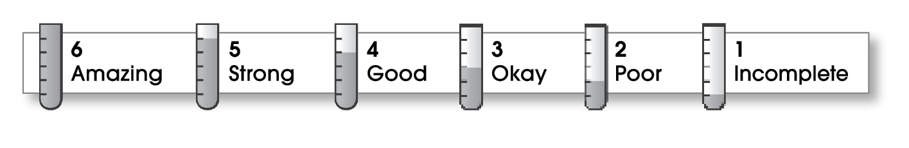

4 | Ideas
The writing . . .
- presents a clearly stated thesis that focuses on plot, characterization, setting, or theme.
- includes specific details and quotations from the text to develop or support the thesis.
4 | Organization
- follows a specific pattern of organization: chronological, order of importance, or logical order.
- contains an effective beginning, middle, and ending.
- includes transitions as needed to connect ideas and paragraphs.
4 | Voice
- sounds believable and informed.
- reflects the writer’s clear understanding of the literature.
4 | Word Choice
- exhibits a careful choice of words.
- explains unfamiliar terms.
5 | Sentence Fluency
- flows smoothly from one idea to the next.
5 | Conventions
- follows the standards for punctuation, capitalization, spelling, and grammar.
- cites quotations correctly.

Comments: Your summary report highlights the most important parts of Catherine, Called Birdy. However, it would have been helpful to know a bit more detail about the different parts: For example, what is Catherine like? How does she get along with her parents and her nurse? And what happens when she runs away?
Your report is clear and free of careless errors.
© Thoughtful Learning For Write on Course 20-20 and All Write

