Response Rubric
Name: |  | Title:
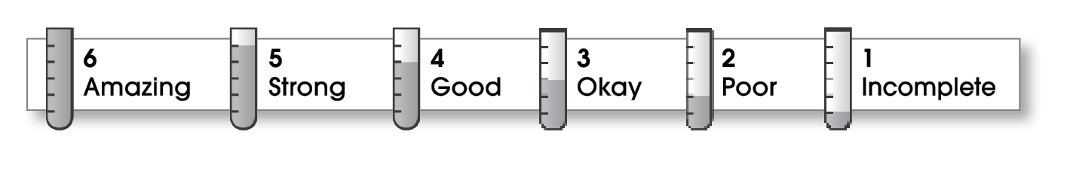

Ideas
The writing . . .
- presents a clearly stated thesis that focuses on plot, characterization, setting, or theme.
- includes specific details and quotations from the text to develop or support the thesis.
Organization
- follows a specific pattern of organization: chronological, order of importance, or logical order.
- contains an effective beginning, middle, and ending.
- includes transitions as needed to connect ideas and paragraphs.
Voice
- sounds believable and informed.
- reflects the writer’s clear understanding of the literature.
Word Choice
- exhibits a careful choice of words.
- explains unfamiliar terms.
Sentence Fluency
- flows smoothly from one idea to the next.
Conventions
- follows the standards for punctuation, capitalization, spelling, and grammar.
- cites quotations correctly.

Comments:
© Thoughtful Learning For Write on Course 20-20 and All Write

