Portfolio Evaluation
Name: |  | Date:
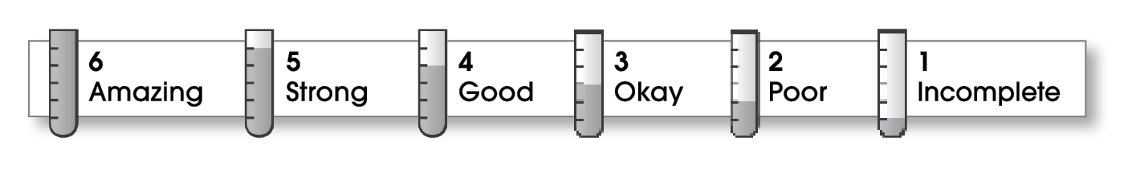

Prewriting
- Chooses appropriate topics.
- Uses a selecting activity, such as clustering, freewriting, or listing.
- Discusses topics before writing.
Writing
- Collects details by gathering thoughts, researching, and talking to others.
- Thinks of ways to organize the details.
- Identifies a focus for writing.
- Uses graphic organizers when appropriate.
- Writes a first draft.
Revising
- Rereads the draft and asks another person to read it.
- Revises the content and changes the parts that are unclear or out of order.
Editing
- Checks the revised draft for spelling, punctuation, and grammar errors.
- Asks another person to check the writing for errors.
- Proofreads the final copy.
Publishing
- Shares the work with classmates, friends, and family.
Overall
- Participates actively in group or peer conferences.
- Writes regularly in a journal.
- Writes in other classes.
- Writes to communicate (email, notes).
- Enjoys creative writing (poetry, stories, scripts).

Comments:
© Thoughtful Learning For Write on Course 20-20 and All Write

