Narrative Rubric
Name: |  | Title:
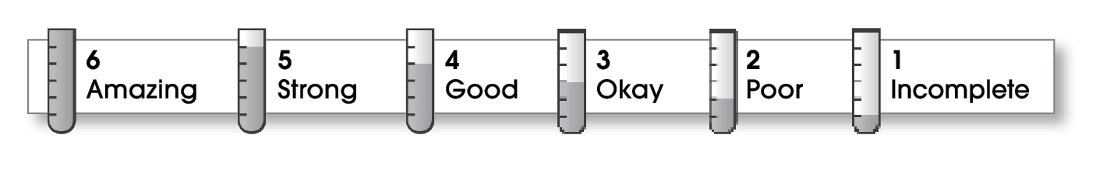

Ideas
The writing . . .
- focuses on a specific experience or time in the writer’s life.
- uses sensory details and dialogue to show rather than tell.
- makes the reader want to know what happens next.
Organization
- pulls the reader into the story.
- includes a beginning, a middle, and an ending.
- gives the events in an order that is easy to follow.
Voice
- shows the writer’s personality.
- sounds honest and engaging.
Word Choice
- contains specific nouns, vivid verbs, and colorful modifiers.
Sentence Fluency
- flows smoothly from one idea to the next.
- uses a variety of sentence lengths and beginnings.
Conventions
- uses correct punctuation, capitalization, spelling, and grammar.
- uses the format provided by the teacher or follows another effective design.

Comments:

© Thoughtful Learning For Write on Course 20-20 and All Write

