Narrative Rubric
Name: |  | Title: | My Summer in Michigan
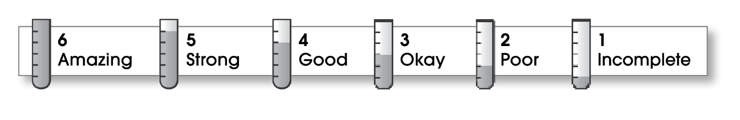

4 | Ideas
The writing . . .
- focuses on a specific experience or time in the writer’s life.
- uses sensory details and dialogue to show rather than tell.
- makes the reader want to know what happens next.
3 | Organization
- pulls the reader into the story.
- includes a beginning, a middle, and an ending.
- gives the events in an order that is easy to follow.
3 | Voice
- shows the writer’s personality.
- sounds honest and engaging.
3 | Word Choice
- contains specific nouns, vivid verbs, and colorful modifiers.
2 | Sentence Fluency
- flows smoothly from one idea to the next.
- uses a variety of sentence lengths and beginnings.
3 | Conventions
- uses correct punctuation, capitalization, spelling, and grammar.
- uses the format provided by the teacher or follows another effective design.

Comments: This is an interesting story, but your introduction doesn’t grab the reader’s attention. It would have been more effective to start in the middle of the action rather than just saying, “It was fun.” It also would have been effective to use more sensory details to describe the woods, the porcupine, your injury, and the cabin.
Many of your sentences are about the same length. By combining these sentences, your narrative would have read more smoothly.

© Thoughtful Learning For Write on Course 20-20 and All Write

