Narrative Rubric
Name: |  | Title: | My Resident Edith
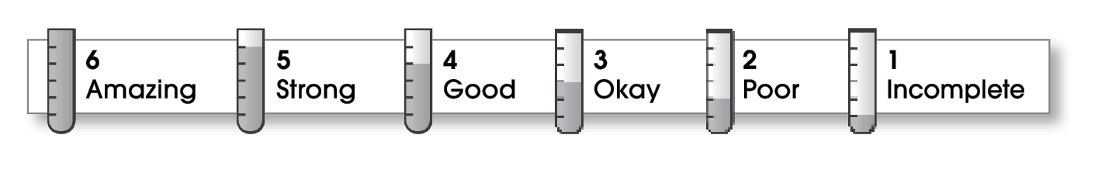

3 | Ideas
The writing . . .
- focuses on a specific experience or time in the writer’s life.
- uses sensory details and dialogue to show rather than tell.
- makes the reader want to know what happens next.
2 | Organization
- pulls the reader into the story.
- includes a beginning, a middle, and an ending.
- gives the events in an order that is easy to follow.
4 | Voice
- shows the writer’s personality.
- sounds honest and engaging.
3 | Word Choice
- contains specific nouns, vivid verbs, and colorful modifiers.
3 | Sentence Fluency
- flows smoothly from one idea to the next.
- uses a variety of sentence lengths and beginnings.
3 | Conventions
- uses correct punctuation, capitalization, spelling, and grammar.
- uses the format provided by the teacher or follows another effective design.

Comments: Your subject sounds like a very interesting and likeable person. Your writing voice is quite strong and reveals your special relationship with her. However, your writing lacks a strong opening to grab the reader’s attention. In addition, the second and fourth paragraphs give a lot of the same type of information.
Make sure to have a reliable editor check your writing for careless errors before publishing it.

© Thoughtful Learning For Write on Course 20-20 and All Write

