Explanatory Rubric
Name: |  | Title: | My Personal Values
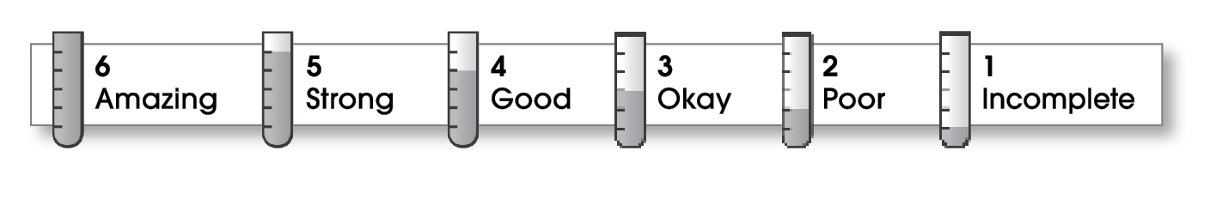

3 | Ideas
The writing . . .
- includes a clear, effective thesis statement.
- provides a variety of interesting details to support it.
3 | Organization
- begins by capturing the reader’s interest and providing the thesis statement.
- has an effectively organized middle.
- focuses on one main point for each middle paragraph.
- ends by summarizing the ideas and giving the reader a final thought.
4 | Voice
- has a voice that shows knowledge of the topic.
- has a voice that engages the reader.
3 | Word Choice
- uses precise nouns and active verbs.
3 | Sentence Fluency
- uses a variety of sentence lengths and beginnings.
- flows smoothly from one sentence to another.
3 | Conventions
- uses end punctuation and commas correctly.
- correctly capitalizes first words and proper nouns.
- avoids spelling errors.
- correctly uses words (there, they’re, their).

Comments: You have expressed a clear thesis or focus statement. However, your essay lacks enough specific detail to support your thesis effectively. For example, what happened to your family? What are your goals for education?
Your essay is easy to follow, but it would read more smoothly if you had combined some of your shorter sentences.

© Thoughtful Learning For Write on Course 20-20 and All Write

