Explanatory Rubric
Name: |  | Title: | Mount Rushmore’s Famous Faces
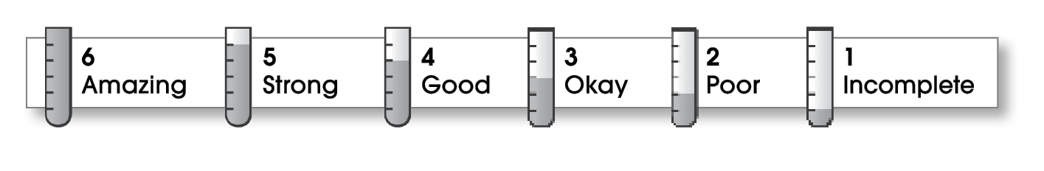

4 | Ideas
The writing . . .
- includes a clear, effective thesis statement.
- provides a variety of interesting details to support it.
6 | Organization
- begins by capturing the reader’s interest and providing the thesis statement.
- has an effectively organized middle.
- focuses on one main point for each middle paragraph.
- ends by summarizing the ideas and giving the reader a final thought.
5 | Voice
- has a voice that shows knowledge of the topic.
- has a voice that engages the reader.
5 | Word Choice
- uses precise nouns and active verbs.
5 | Sentence Fluency
- uses a variety of sentence lengths and beginnings.
- flows smoothly from one sentence to another.
5 | Conventions
- uses end punctuation and commas correctly.
- correctly capitalizes first words and proper nouns.
- avoids spelling errors.
- correctly uses words (there, they’re, their).

Comments: The organization of your essay is outstanding. The thesis statement tells the reader what the organization will be. The next four paragraphs carry out the organizational plan. Your ideas are easy to follow from start to finish.
Are the facts about Einstein complete and correct? You probably should have mentioned more specifically what Einstein contributed and explained more thoroughly the inventions he made possible.

© Thoughtful Learning For Write on Course 20-20 and All Write

