Argument Rubric
Name: |  | Title: | Letter to the Editor (Art)
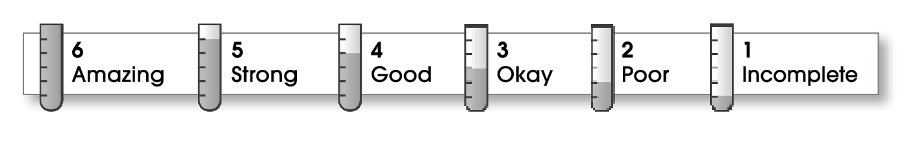

5 | Ideas
The writing . . .
- includes a clear, effective opinion statement.
- provides a variety of reasons to support the opinion statement.
- effectively answers objections.
4 | Organization
- begins well by capturing the reader’s interest and providing the opinion statement.
- effectively organizes the middle part.
- focuses on one main reason in each middle paragraph.
- ends well by reviewing the reasons and revisiting the opinion statement.
4 | Voice
- shows that the writer cares about the topic.
- uses an appropriate emotional tone.
4 | Word Choice
- uses precise nouns and active verbs.
4 | Sentence Fluency
- uses a variety of sentence lengths and beginnings.
- flows smoothly from one sentence to another.
5 | Conventions
- uses end punctuation and commas correctly.
- correctly capitalizes first words and proper nouns.
- avoids spelling errors.
- correctly uses words (there, they’re, their).

Comments: This is a very heartfelt and timely letter, and your voice comes through loud and clear. Perhaps you could have included more details about the arts being slighted in your particular school. Also, you need to address the issues raised by those who do feel that the arts are “extras.”
Overall, this is quite a well-written piece, free of mechanical errors.

© Thoughtful Learning For Write on Course 20-20 and All Write

