Explanatory Rubric
Name: |  | Title: | Iron Summary (Okay)
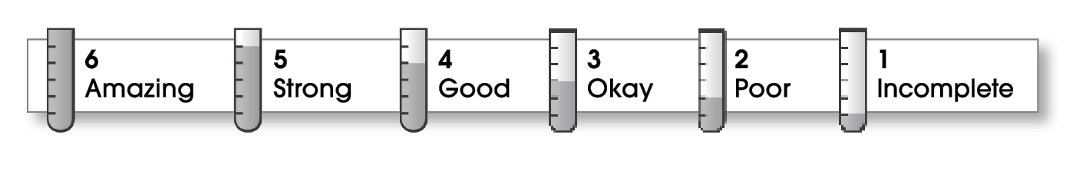

2 | Ideas
The writing . . .
- includes a clear, effective thesis statement.
- provides a variety of interesting details to support it.
4 | Organization
- begins by capturing the reader’s interest and providing the thesis statement.
- has an effectively organized middle.
- focuses on one main point for each middle paragraph.
- ends by summarizing the ideas and giving the reader a final thought.
3 | Voice
- has a voice that shows knowledge of the topic.
- has a voice that engages the reader.
4 | Word Choice
- uses precise nouns and active verbs.
3 | Sentence Fluency
- uses a variety of sentence lengths and beginnings.
- flows smoothly from one sentence to another.
4 | Conventions
- uses end punctuation and commas correctly.
- correctly capitalizes first words and proper nouns.
- avoids spelling errors.
- correctly uses words (there, they’re, their).

Comments: You do a very thorough job of covering the material in the original reading selection; perhaps a little too thorough. A summary should be a shorter version of the original, covering only the main idea and important details. Your summary is nearly as long as the original and is a retelling in your own words, which is called a paraphrase.
Go back and highlight only the most important details to support the main idea. writing.
© Thoughtful Learning For Write on Course 20-20 and All Write

