Explanatory Rubric
Name: |  | Title: | I Have a Dream . . . Too
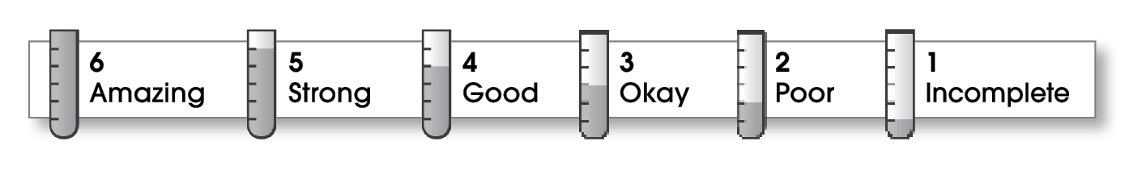

3 | Ideas
The writing . . .
- includes a clear, effective thesis statement.
- provides a variety of interesting details to support it.
3 | Organization
- begins by capturing the reader’s interest and providing the thesis statement.
- has an effectively organized middle.
- focuses on one main point for each middle paragraph.
- ends by summarizing the ideas and giving the reader a final thought.
3 | Voice
- has a voice that shows knowledge of the topic.
- has a voice that engages the reader.
2 | Word Choice
- uses precise nouns and active verbs.
3 | Sentence Fluency
- uses a variety of sentence lengths and beginnings.
- flows smoothly from one sentence to another.
3 | Conventions
- uses end punctuation and commas correctly.
- correctly capitalizes first words and proper nouns.
- avoids spelling errors.
- correctly uses words (there, they’re, their).

Comments: Although your essay is well-organized and fairly free of mechanical errors, it lacks specific detail. It also has too much repetition, and the conclusion is a word-for-word restatement of your opening. More specific detail about the lifestyle you would like to have and especially about the difference you would like to make in children’s lives would have made your essay more effective.

© Thoughtful Learning For Write on Course 20-20 and All Write

