Response Rubric
Name: |  | Title: | Freaky Friday
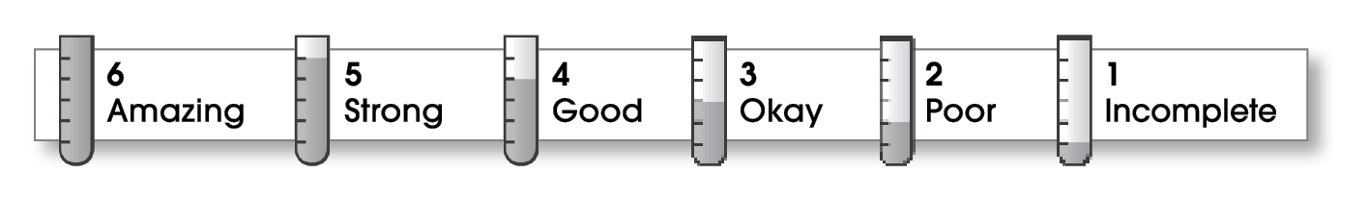

2 | Ideas
The writing . . .
- presents a clearly stated thesis that focuses on plot, characterization, setting, or theme.
- includes specific details and quotations from the text to develop or support the thesis.
3 | Organization
- follows a specific pattern of organization: chronological, order of importance, or logical order.
- contains an effective beginning, middle, and ending.
- includes transitions as needed to connect ideas and paragraphs.
3 | Voice
- sounds believable and informed.
- reflects the writer’s clear understanding of the literature.
3 | Word Choice
- exhibits a careful choice of words.
- explains unfamiliar terms.
2 | Sentence Fluency
- flows smoothly from one idea to the next.
3 | Conventions
- follows the standards for punctuation, capitalization, spelling, and grammar.
- cites quotations correctly.

Comments: You touch on many literary elements (setting, character, plot, and theme) without any clear reason. As a result, your review lacks focus. What is it that you are trying to accomplish? Including details from the novel would have made your review stronger.
You need to pay closer attention to conventions in your review, especially spelling. Errors make your response difficult to read in places.
© Thoughtful Learning For Write on Course 20-20 and All Write

