Narrative Rubric
Name: |  | Title: | Dear Mr. Rhys
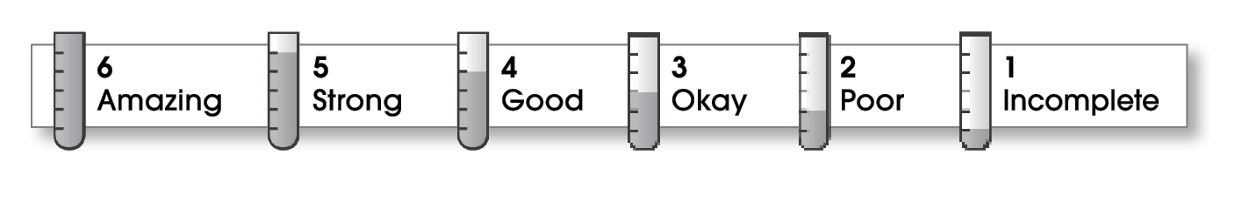

6 | Ideas
The writing . . .
- focuses on a specific experience or time in the writer’s life.
- uses sensory details and dialogue to show rather than tell.
- makes the reader want to know what happens next.
6 | Organization
- pulls the reader into the story.
- includes a beginning, a middle, and an ending.
- gives the events in an order that is easy to follow.
6 | Voice
- shows the writer’s personality.
- sounds honest and engaging.
5 | Word Choice
- contains specific nouns, vivid verbs, and colorful modifiers.
6 | Sentence Fluency
- flows smoothly from one idea to the next.
- uses a variety of sentence lengths and beginnings.
6 | Conventions
- uses correct punctuation, capitalization, spelling, and grammar.
- uses the format provided by the teacher or follows another effective design.

Comments: The focus of your biographical writing is clearly stated and very effectively supported from start to finish. The letter format works extremely well, immediately engaging the reader’s interest.
Perhaps more attention to word choice (strong action words and colorful modifiers) would have made your letter even better.

© Thoughtful Learning For Write on Course 20-20 and All Write

