Explanatory Rubric
Name: |  | Title: | Turkey Day
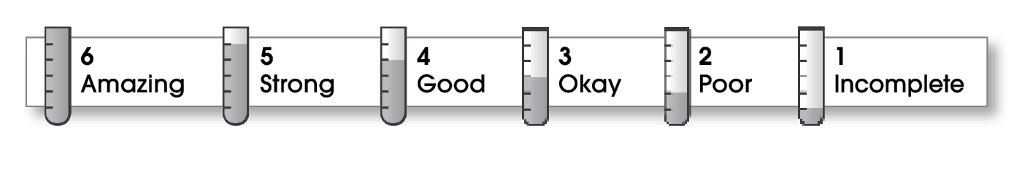

4 | Structure
- The writing has a beginning, a middle, and an ending.
- The details follow a clear order.
3 | Ideas
- The writing has an interesting topic.
- Details make the topic clear.
- Sentences are easy to read.
- The writing uses specific words.
3 | Correctness
- A capital letter begins each sentence and name.
- Sentences end with correct punctuation.
- Common words have correct spelling.

Comments: You did a nice job of including beginning, middle, and ending parts. I like the details you shared about Thanksgiving. If you shared some more specific details, your writing would be even better. Starting your sentences in a few different ways would make your writing easier to read. Finally, remember to capitalize first words and months of the year.

© Thoughtful Learning For Write Away

