Narrative Rubric
Name: |  | Title: | The Horrible Day
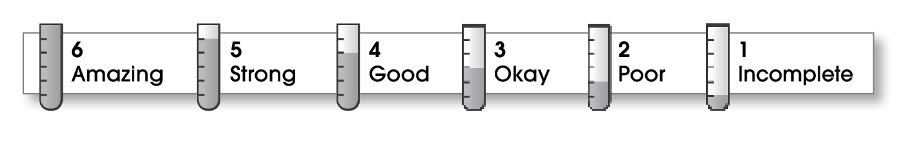

5 | Structure
- The writing has a beginning, a middle, and an ending.
- The order of events makes sense.
5 | Ideas
- The narrative focuses on a personal experience.
- The writer describes how things look, sound, smell, taste, and feel.
- Sentences are easy to read.
- Strong verbs make the action come alive.
5 | Correctness
- A capital letter begins each sentence and name.
- Sentences end with correct punctuation.
- Common words have correct spelling.

Comments: This is a fun story to share out loud. It includes a strong beginning, middle, and ending. It also has lots of details and a personal voice.

© Thoughtful Learning For Write Away

