Book-Review Rubric
Name: |  | Title: | Snowflake Bentley
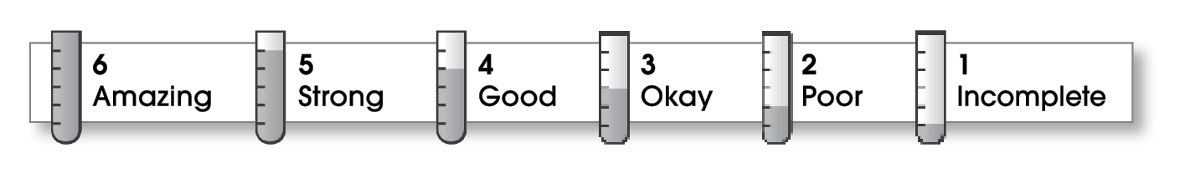

2 | Structure
- The writing has a beginning, a middle, and an ending.
- The details follow a clear order.
1 | Ideas
- The writing focuses on a book or story.
- Details help the reader understand.
- The writer shares an opinion or feeling about the story.
- Sentences are easy to read.
- The writing uses specific words.
3 | Correctness
- A capital letter begins each sentence and name.
- Sentences end with correct punctuation.
- Common words have correct spelling.

Comments: Your review gives the title of the book and the author, but no details about the book. You need to take more time to explain what you learned in the book and to share feelings about it.

© Thoughtful Learning For Write Away

