Book-Review Rubric
Name: |  | Title: | Julius the Baby of the World
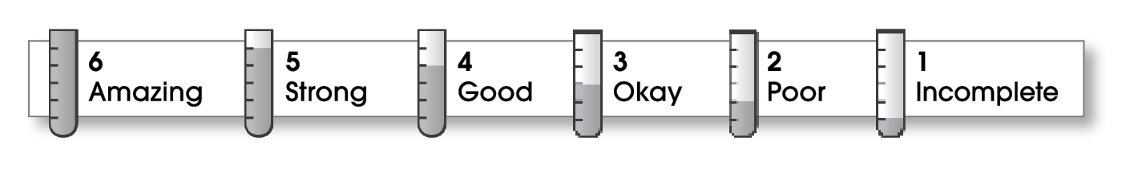

5 | Structure
- The writing has a beginning, a middle, and an ending.
- The details follow a clear order.
5 | Ideas
- The writing focuses on a book or story.
- Details help the reader understand.
- The writer shares an opinion or feeling about the story.
- Sentences are easy to read.
- The writing uses specific words.
5 | Correctness
- A capital letter begins each sentence and name.
- Sentences end with correct punctuation.
- Common words have correct spelling.

Comments: Your review includes strong details about the content of the book, and it also tells why you liked the book. The sentences all make sense, and the copy is accurate. Well done!

© Thoughtful Learning For Write Away

