Explanatory Rubric
Name: |  | Title: | Happy Halloween
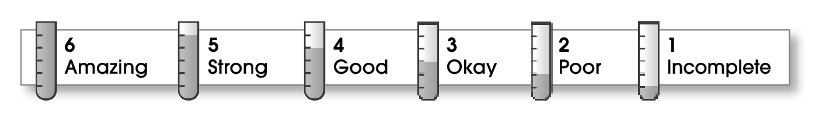

4 | Structure
- The writing has a beginning, a middle, and an ending.
- The details follow a clear order.
5 | Ideas
- The writing has an interesting topic.
- Details make the topic clear.
- Sentences are easy to read.
- The writing uses specific words.
4 | Correctness
- A capital letter begins each sentence and name.
- Sentences end with correct punctuation.
- Common words have correct spelling.

Comments: I really liked your explanation of Halloween. Nice job with your description of “spooky” decorations. Make sure to check for spelling errors.

© Thoughtful Learning For Write Away

