Narrative Rubric
Name: |  | Title: | Friday
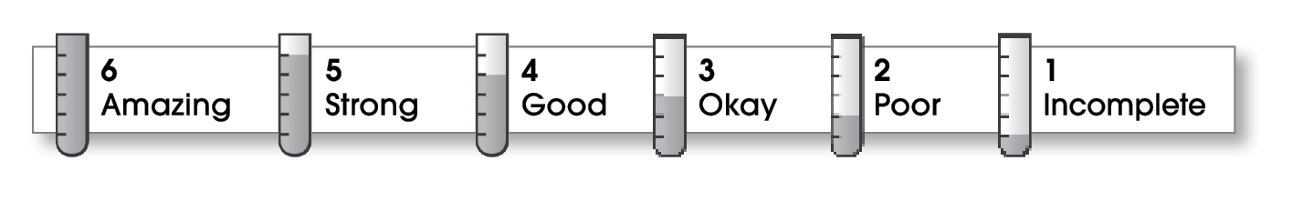

3 | Structure
- The writing has a beginning, a middle, and an ending.
- The order of events makes sense.
3 | Ideas
- The narrative focuses on a personal experience.
- The writer describes how things look, sound, smell, taste, and feel.
- Sentences are easy to read.
- Strong verbs make the action come alive.
3 | Correctness
- A capital letter begins each sentence and name.
- Sentences end with correct punctuation.
- Common words have correct spelling.

Comments: Your story has a promising beginning and interesting details. You need to work on organizing your story and proofreading for spelling errors.

© Thoughtful Learning For Write Away

